OP2 Additional Reviewer Group Limitations Developments

**Requirements:**

The development was related to "Define group limitation for reviewer process"  
1. We have added a option to Define group limitation in workflow form section just next to add reviewer.  
2. From where user can select one or multiple groups. after that only these group will be available when user will add reviewer on project form.  
3. Also, we have added two options at the same page 1-"Only Selected COS node" and 2-"All COS node" where user can select only one at a time.  
4. On the basis of above selection user list will be filtered when user will add reviewer on project form.  
In the case of 1st option only those users will be available which have access on the node on which the current opened project is created.

**Functionality:**

# **Create Object:**

**For project creation go to the Credit Register and click on new icon.**

Main Menu > Credid > Add Icon > Open pop-up

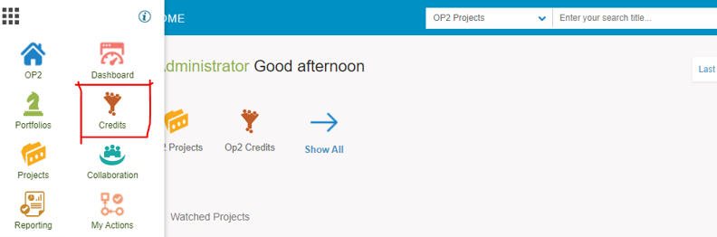

**Below screenshot is Credit register and click on add icon for Object creation.**

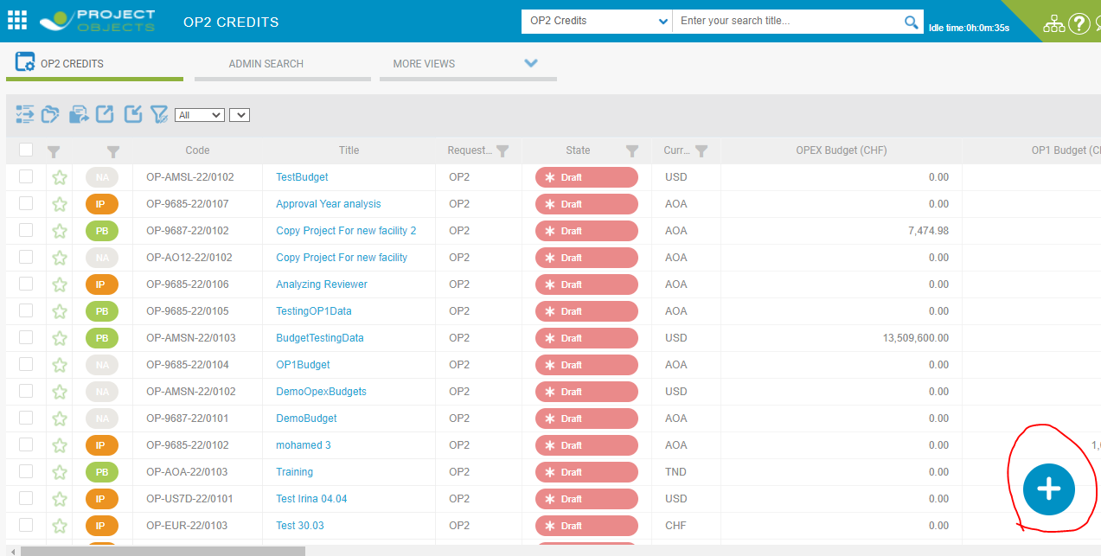

**Then After, here is visible a Pop-up for Object Creation and fill all the required fields respectively and save.**

**If you select the Save n Edit option then you would be redirecting the Object details page**.

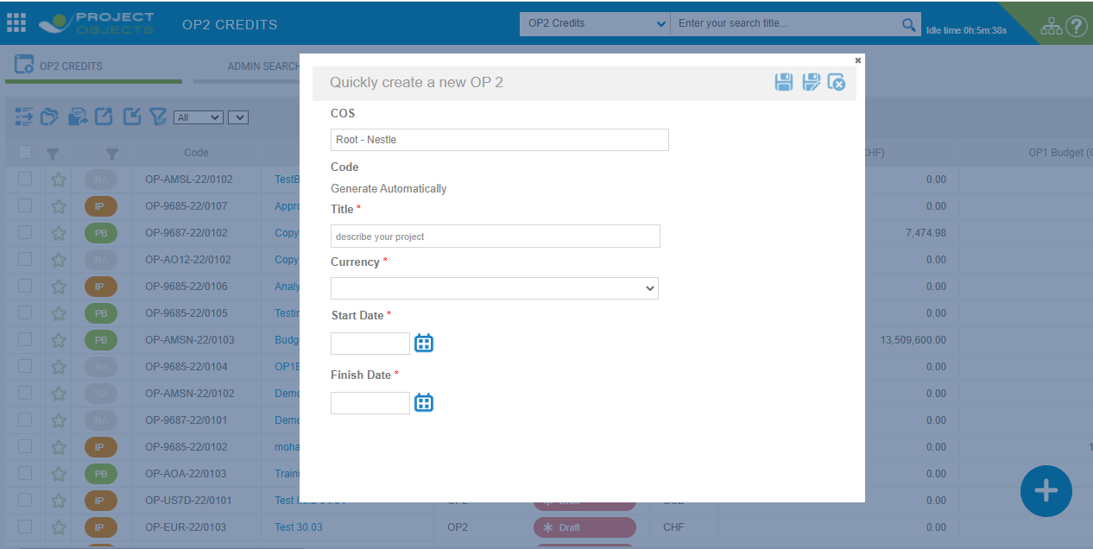

**After filled all requirements then click save.**

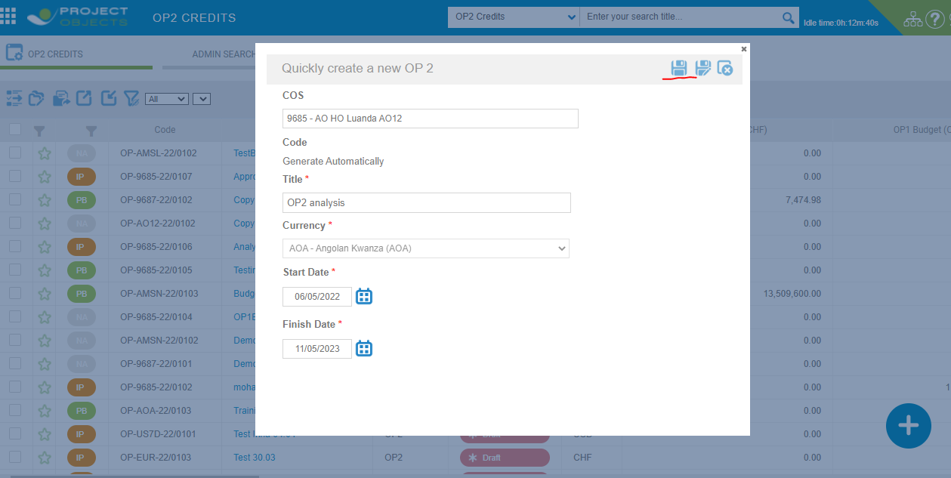

Then after we click on object in credit register and go to the project Detail page and we fill all required fields respectively.

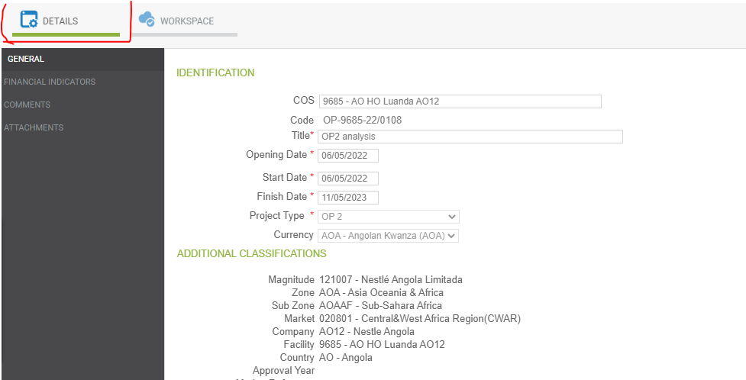

**2nd Step:**  Fill the cost element data

Then after, select tab workspace and then select tab of Cost element data, In Cost element data we define the budget of OP1 and OP2 (Original budget) of particular Object and put up the budget values of OP1 and OP2 element types.

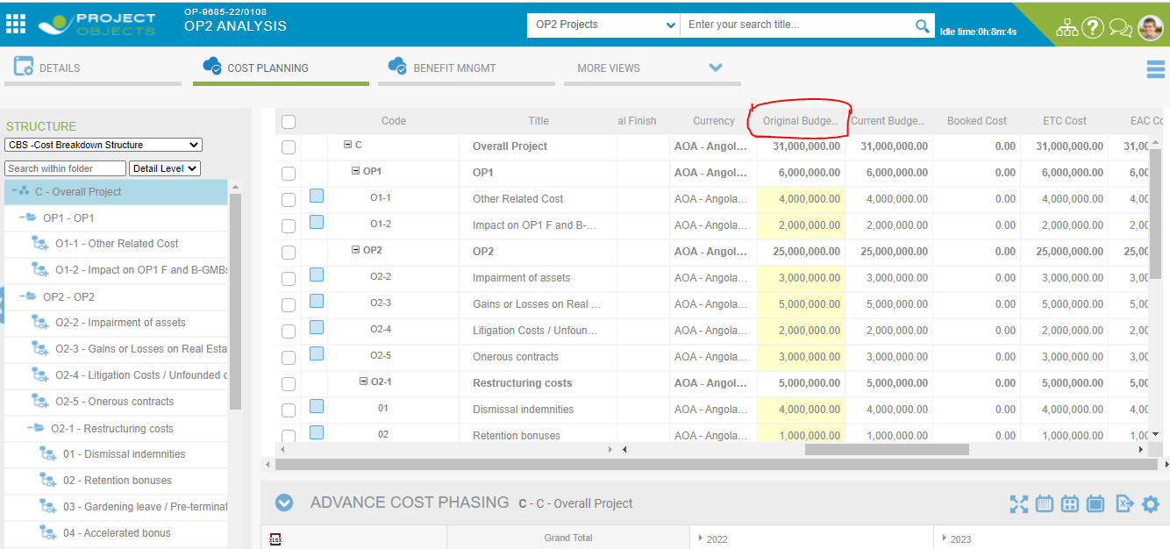

# **Additional Reviewer Required When we release the object.**

In Object when we release the first step of object, we can add a reviewer from two method in additional reviewer.

1. From Reviewer Section in Workflow designer.
2. From Object.

**1:** From Reviewer Section in Workflow designer.

**Company Settings > Workflow Designer > Select project in dropdown > Select workflow > Reviewer Configuration.**

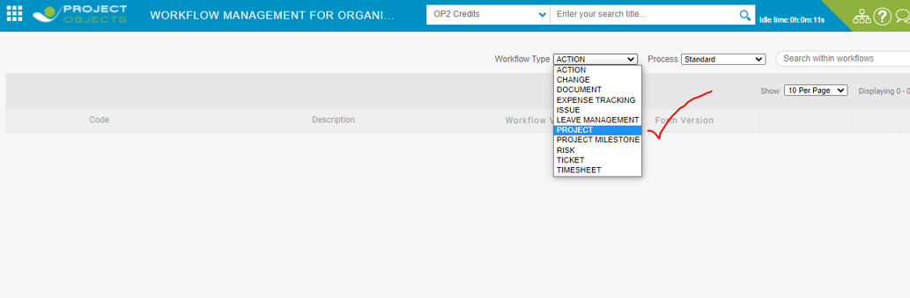

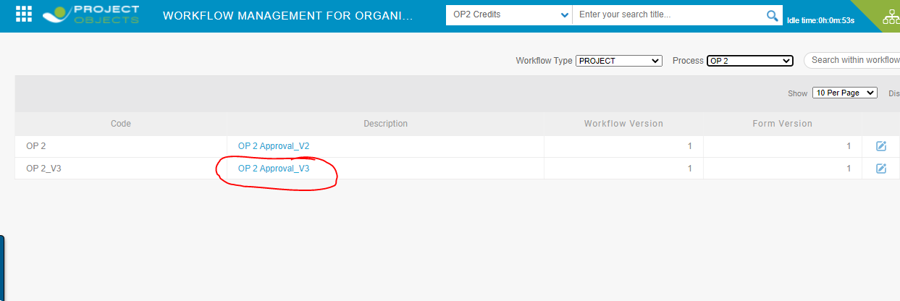

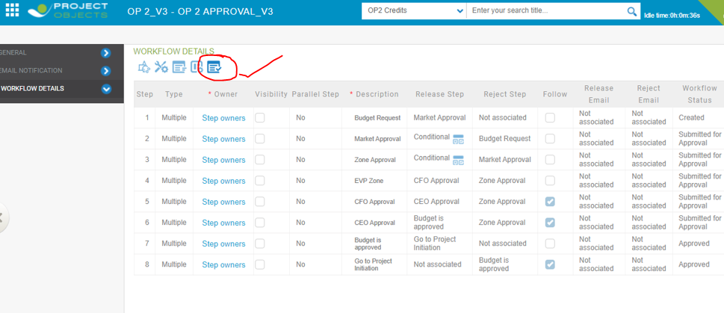

In additional reviewer review section orange icon is Define Group Limitation is here.

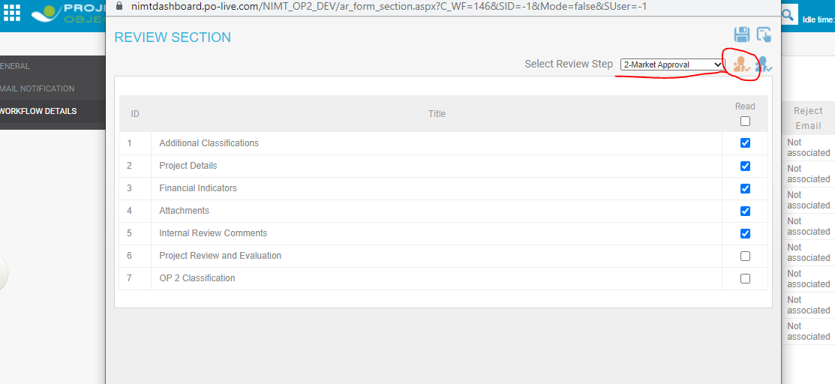

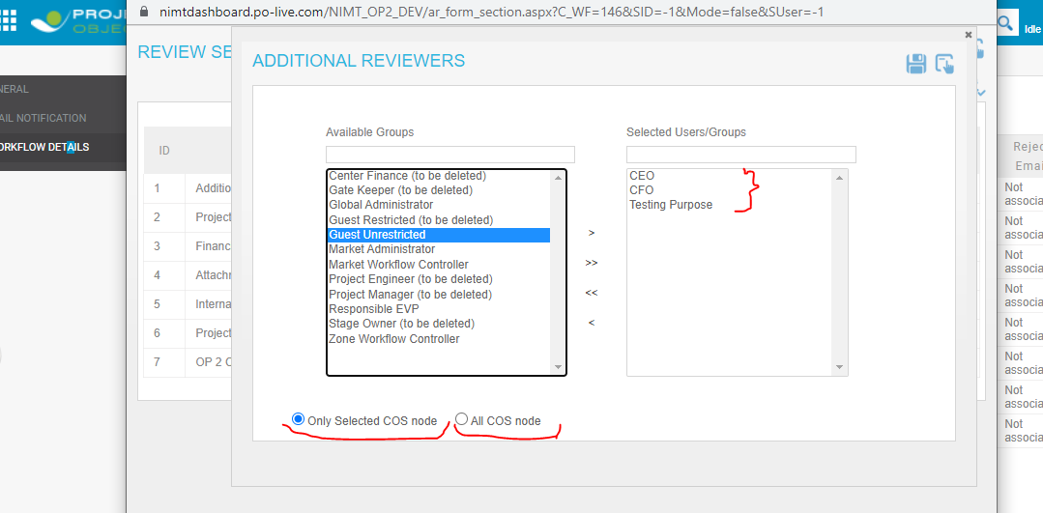

In review section here is two options “only selected COS node” and “All COS Node”, Here User can select any one at a same time.

After this when users create any new object then Selected groups or Users comes in additional reviewer pop-ups by default.

**2: From Object**

Go to the credit register, select object and go to Object detail page and select Additional reviewer icon.

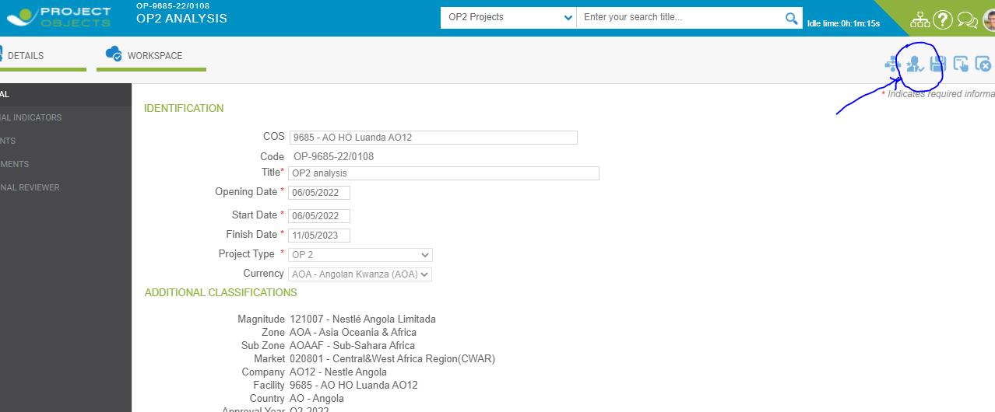

select reviewer for a step in Additional reviewer and save.

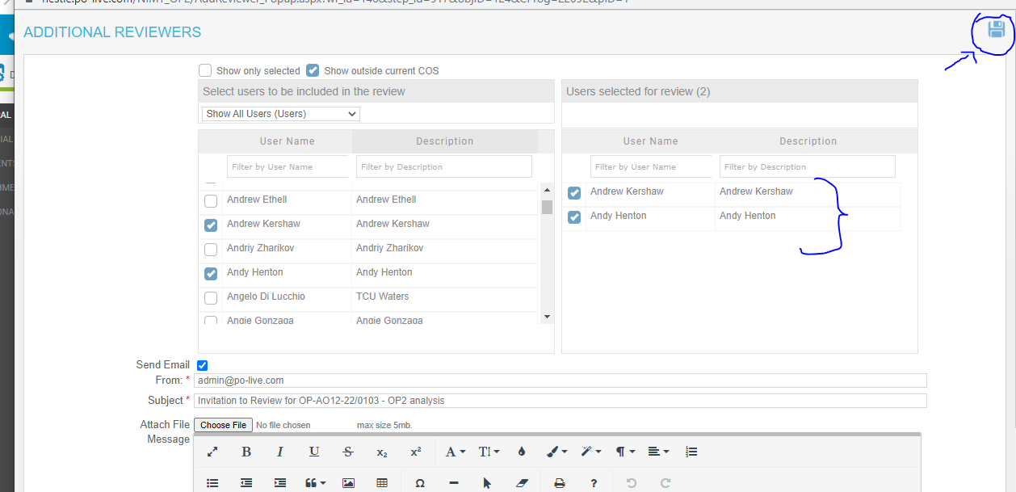

Reviewer is visible in Additional reviewer section which is in Project detail page see below screenshot.

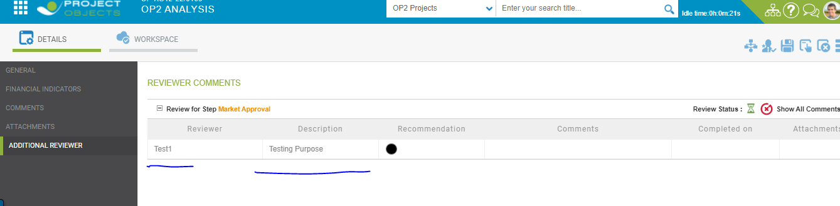

Particular Object you had selected as reviewer So, it is also visible for particular user in my action page who is able to give their comment in object comment section, so here basically we are login from that user name and release the steps with their comments.

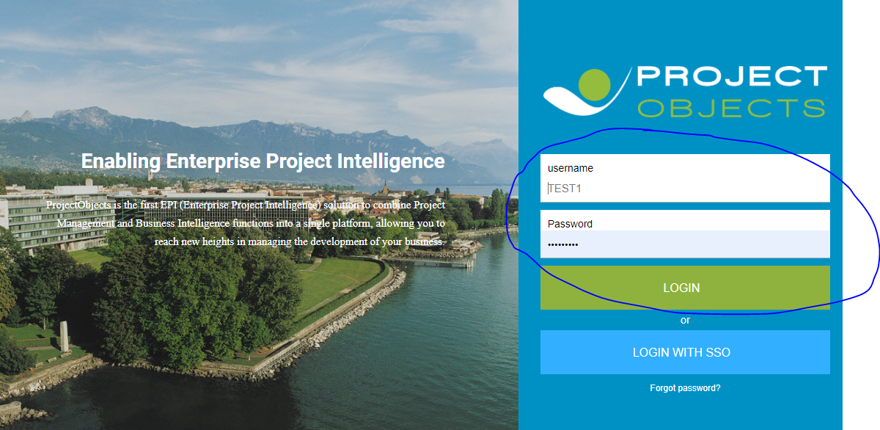

After login of that user which is as reviewer of particular object is visible in My action page.

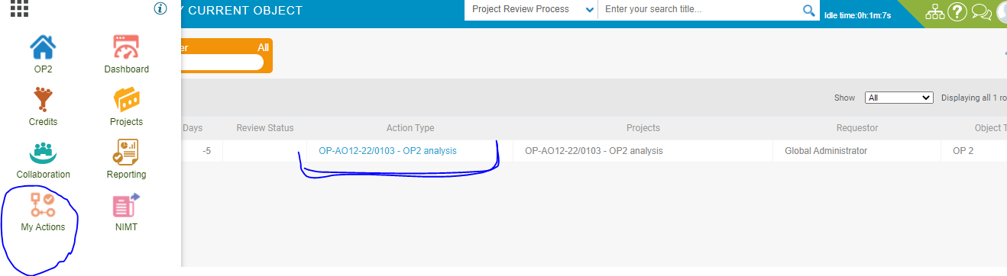



After comment and log off that particular user from application and login from global admin , go to the object comment section, the black dot would be visible green.

# **Conditional development:**

In this development, when groups are assigned over particular COS parent node in additional reviewer (Workflow Designer) then it is all applicable for child node, means If you create object over child node of that parent where main groups are assigned, then that user or group will be visible in additional reviewer Pop-up as a reviewer.

Add the group from additional reviewer from company settings and save.

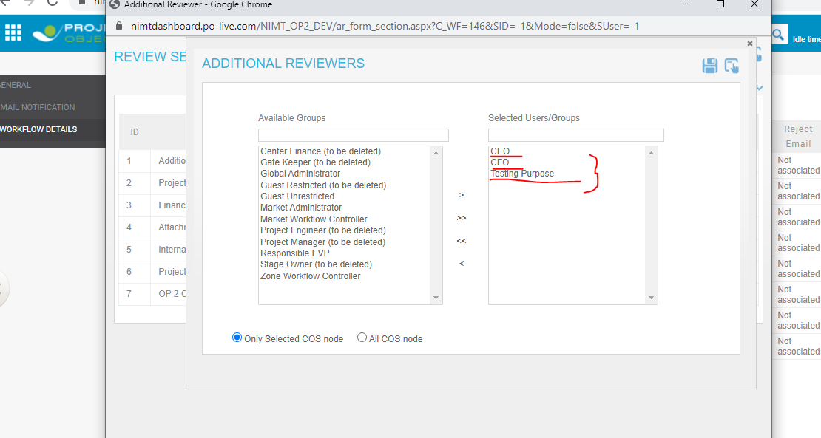

We choose here Test 1 User and all three groups are assigned to be this User.

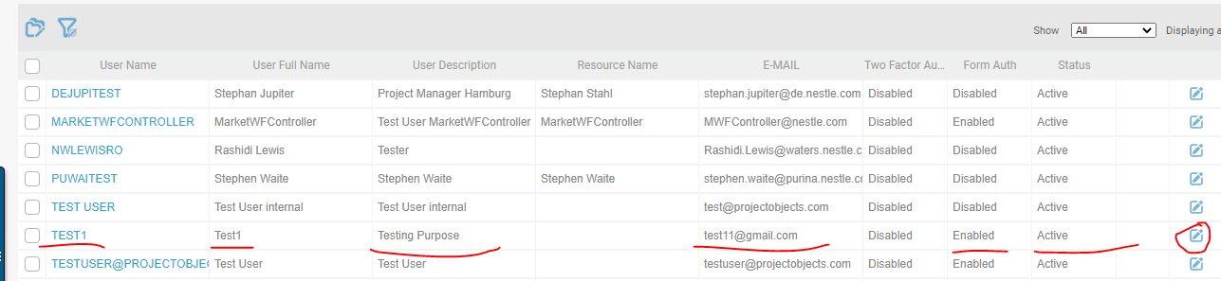

Take Parent node of COS AOA.

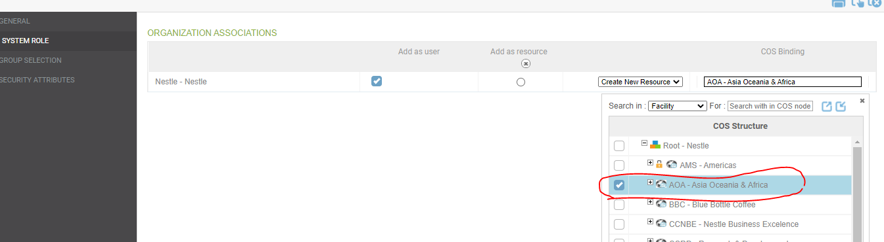

Then after this we proceed to assign all group.

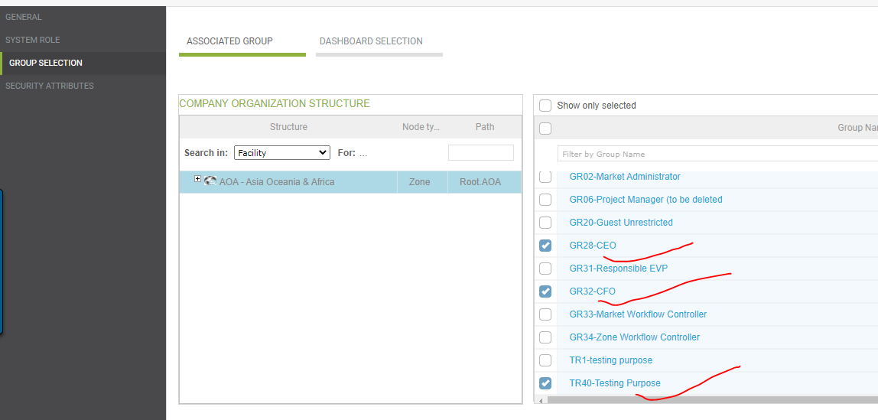

Now we create object any facility under COS AOA.

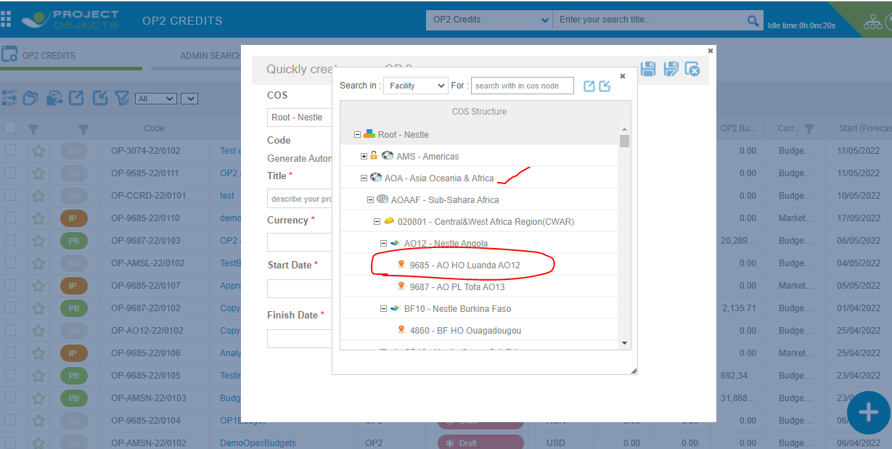

After create the object and go to the edit page and click on additional reviewer.

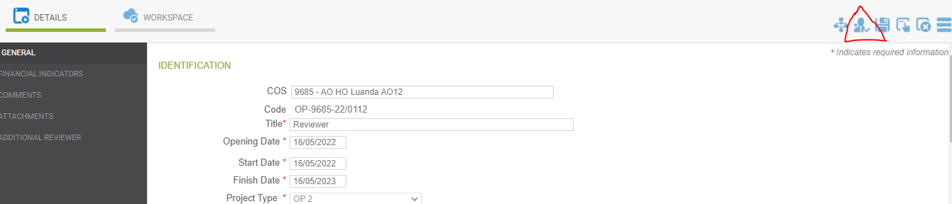

In additional reviewer pop-up dropdown selection of group, our user is visible here.

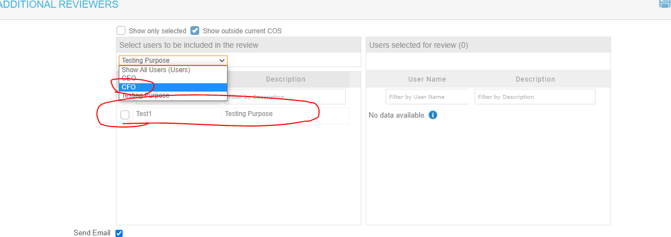

**Thank You…**